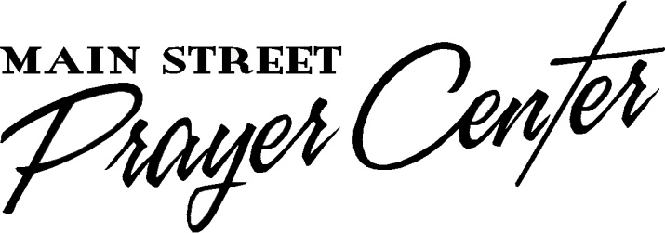
Healing Rooms of Hopkins County
35 North Main Street, Madisonville KY 42431
(270) 821-6030
www.mainstreetprayer.org
prayer@mainstreetprayer.org

Open
Tuesdays 4:00-5:00 PM & 7:00-9:00 PM
Thursdays 2:00-4:00 PM & 7:00-9:00 PM

No Appointment Necessary
No Fee

