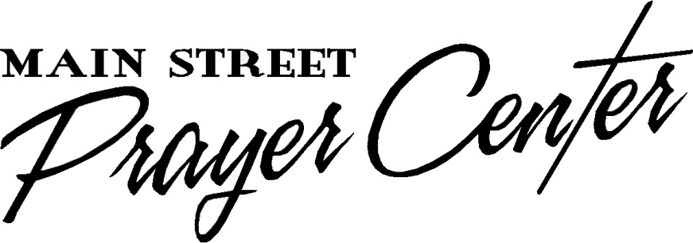
Healing Rooms of Hopkins County
35 North Main Street
Madisonville, Kentucky 42431

Name: ___________________________ Date: _____________________

We gratefully acknowledge your gift of $__________ by check number ____________.
(No goods or services were rendered in exchange for this gift.)

Your financial support enables others the opportunity to experience the healing love and grace of our Lord Jesus Christ. It is through your sacrificial giving that we are able to offer healing prayer in the Healing Rooms of Hopkins County. Thank you. May God richly bless and keep you!

Denise M. Spence
Associate Director of Finance & Administration

