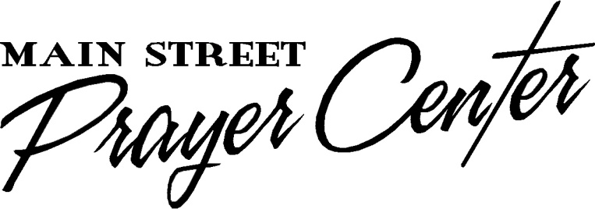
Healing Rooms of Hopkins County

Interview Questions for Prayer Team Member

DATE_____________ NAME____________________________________

While we have a few questions of you we understand you have questions as well. We are going to go first as some of your questions may be answered as we go over ours. What brought you to the training and why do you want to be a part of this healing ministry?

Tell us about your salvation experience and encounters with the Holy Spirit. Would you say you have been filled with the Holy Spirit? How do you know?

This is what might be called a front line ministry. So it is vital that you practice the spiritual disciplines of prayer, study, repentance and worship. Tell us about your personal prayer life. What do you do to be with Jesus? Do you hear from God, journal and have personal worship time? Do you know the term, soaking? Do you practice rest before the Lord?

Can you tell us about experiences you have had when God used you to heal someone physically? Emotionally?

What part of the training was helpful to you? What had the most impact on you? What areas of the training do you still have questions about or have a little different perspective? Other Questions? Concerns? Issues?

