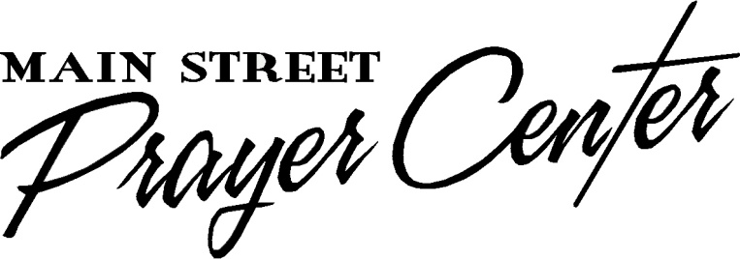
Healing Rooms of Hopkins County
35 North Main Street
Madisonville, Kentucky 42431

Pastor Chad Everett
CrossRoads Bible Church
583 US Hwy 45
Norris City, IL 62869

Dear Pastor Everett,

Healing Rooms of Hopkins County at the Main Street Prayer Center is an ecumenical ministry of people from many different Christian backgrounds and experiences. We have come together in unity to pray for the sick with compassion and faith in Jesus Christ and His power to heal. We are one of more than 1800 Healing Rooms affiliated with the International Association of Healing Rooms and operate under that model of healing prayer.

Peggy Sisco, a member of your church, has completed our Prayer Team Training and has given us permission to contact you. While we desire to be as inclusive as possible, we want to be certain that a Prayer Ministry Team Member has a solid foundation of faith and does not have any serious character or sin issues in their life. Also, we want to be certain that the person’s pastor is in agreement with their serving in this ministry. Therefore, we require pastoral approval for everyone serving in this ministry.

Please help us by completing the following questionnaire about this individual. The contents of this survey are confidential and will not be shared with your church member.

We always thank God, the Father of our Lord Jesus Christ, when we pray for you, because we have heard of your faith in Christ Jesus and of the love you have for all the saints...
Colossians 1: 3-4

Sincerely,

Rush and Barbie Hunt, Co-Directors
QUESTIONNAIRE

Peggy Sisco has given permission for you to complete the following personal survey.

1. Does this person attend regularly at your church? YES / NO (Please circle one)

2. Has this person worshipped and served at your church long enough for you, or those you trust, to have developed some insight into their character? YES / NO (Please circle one)

3. Does this person have a healthy respect for authority? YES / NO (Please circle one)

4. Do you consider this person to be a mature Christian? YES / NO (Please circle one)

5. Please circle one or more areas in which you would recommend this person to serve.
Helping Ministry (Office) Hospitality Ministry (Reception/Greeting)
Intercessory Prayer (Prayer Support) Prayer Ministry Team (Praying with the Sick)

6. Do you have additional comments and/or concerns?
___________________________________________________________________
___________________________________________________________________
___________________________________________________________________
___________________________________________________________________

Signed _____________________________________________ Date ___/___/___
Church Name _________________________________ Phone___________________
Church Address ________________________________________________________
City _____________________________ State ________ Zip Code _______________
Denominational Affiliation_______________________________________________

The contents of this form are confidential and will not be shared with the volunteer.

Please return in the enclosed envelope to: Barbie and Rush Hunt, Directors.
For questions please contact us: Barbie’s cell: 871. 4893 Rush’s cell: 836.4895
Phone number at the Healing Rooms is 270.821.6030; email is prayer@mainstreetprayer.org

