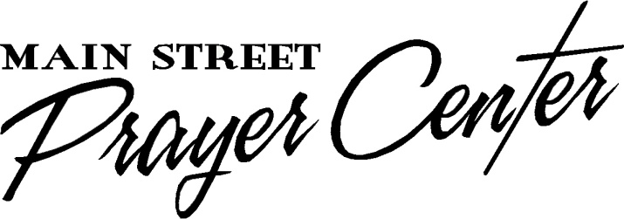
Healing Rooms of Hopkins County
35 North Main Street
Madisonville, Kentucky 42431

Prayer Ministry Team Confidentiality Release Form

As a Healing Rooms Prayer Team Member, I understand that this is not a counseling ministry and I will not do counseling of any kind. These are prayer rooms and I rely upon the Holy Spirit to lead me how to pray. Therefore, I agree that I will never give medical or nutritional advice. An example of nutritional advice would be what vitamins, food, supplements, types of diets or other natural remedies to take. I will encourage people to see their doctors/counselors and to continue taking their medications until their doctors/counselors have released them. In the event that a guest should talk about or mention getting off of their medications, I will encourage them not to stop taking their medication without a doctor’s/counselor’s approval. I will document this communication on the person’s records.

The Healing Rooms of Hopkins County is a confidential, safe place of ministry; therefore, I will not discuss anyone’s session outside of the prayer room.

When giving a prophetic word, I will not give specific names, dates, or time frames. I will not minister any directional or correctional prophecy. Instead, minister positive words, such as encouragement and healing strength.

If I am in a room where any of the above policies have been violated by a team member, I will graciously correct the situation before the guest leaves the room.

I know that I will not be allowed to pray on a team until a signed and dated copy of this document has been received by the Director.

I have read, understand and agree to the above policy information.

_________________________________________ ________________________
Signature Date

_________________________________________
Print Name

